Use-Case Realization Report
Logout

Issue <1.0>
Revision History
Date | Issue | Description | Author
<02/08/09> | <1.0> | <Logout> | <Karen Gao>

Table of Contents
1. Brief Description 4
2. Flow of Events 4
2.1 Standard Flow 4
3. Interaction Diagrams 4
3.1 Collaboration Diagram for Logout 4
4. Participating Objects 4
5. Class Diagrams 5
5.1 Class Diagram for Logout 5
6. Derived Requirements 6

Use-Case Realization Report
Logout

Brief Description
This is the logout process by the User, Portal Administrator or the User Administrator. Upon successful logout, the Portal main Page shall be shown.

Flow of Events

Standard Flow
This use case covers the events of Logout of the MenuPage, the standard flow of events is described as below:
- The Portal Administrator, User Administrator or the User shall exit their MenuPage.
- The operation logout will inform the MenuController to requestLessStatus from the LessonController.
- The LessonController shall send the getStatus command to the Status object and the saveStatus shall be received by the Lessoncontroller.
- Once the MenuController acknowledge by the operation saveStatus, the operation returnPortalMainPage will precede to return to PortalMainPage.

Interaction Diagrams

Collaboration Diagram for Logout
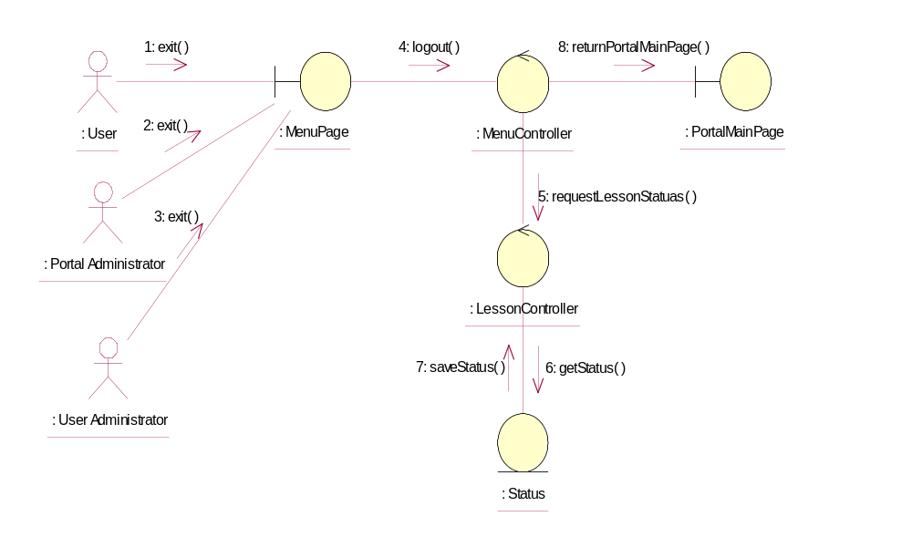

Participating Objects
: LessonController
This Controller manage the status object and liaise with the MenuController.

: MenuController
This Controller shall manage the logout function and liaise with the LessonController before returning the boundary of PortalMainPage.

: MenuPage
This boundary shall be entered by the User, Portal Administrator or the User Administrator.

: Portal Administrator
One of the actors to decide the logout process.

: PortalMainPage
Boundary for login process.

: Status
This object store the status of the Lesson

: User
One of the actors to decide the logout process.

: User Administrator
One of the actors to decide the logout process.

Class Diagrams

Class Diagram for Logout
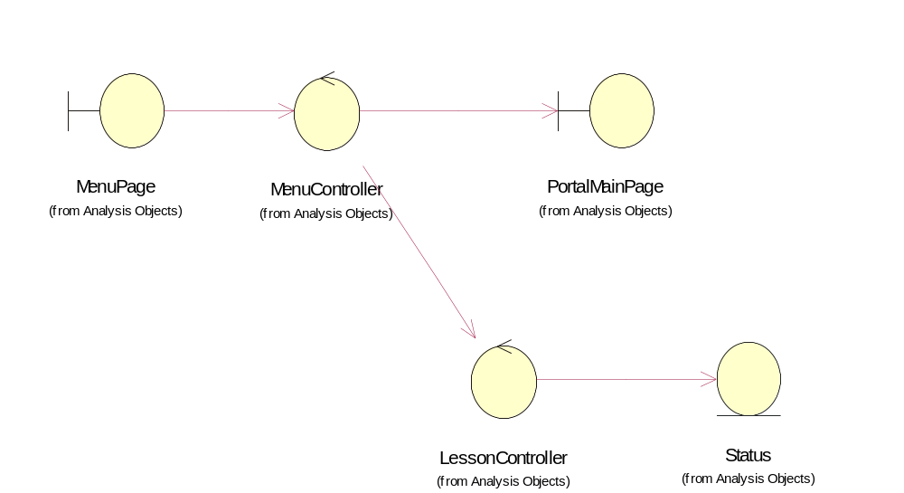

Derived Requirements
Portal Administrator, User Administrator and User all can access the MenuPage and Portal Main Page according to their pre-defined role.

